# INTRODUCTION

Ticks of the Ixodes ricinus (L.) complex (hereafter Ixodes ticks) are vectors of numerous arthropod-borne pathogens of medical and veterinary importance. Ticks are obligate hematophagous ectoparasites associated with the transmission of viruses, bacteria, and protozoa, which affect both human and animal health. The risk of ticks acquiring pathogens could be connected to the distribution and abundance of pathogens in the environment. In the course of completing its lifecycle, ticks must engage a couple of mammalian hosts to obtain blood meal. Upon engorgement, ticks drop off enabling moulting into the next developmental stage [3]. The newly-moulted ticks begin a quest for another host, in which period, it could acquire a range of pathogens. High rate of soil and grass contamination with microbes and particularly with infective parasites is usually the case in many places

# **RESULTS**

A total of 510 ticks were collected from the 30 cattle inspected. The ticks belonged to four (4) distinct species: *Amblyomma variegatum* (189), *Hyalomma impressum* (229), *Boophilus geigyi* (83) and *R. sangiuneus* (9). The number of ticks collected across the predilection sites is presented in Table 1. The highest collections were made from the belle (99) and the least from the shoulders (63). Overall, 24 cattle were affected in at least one predilection area of their body, resulting in a prevalence of 80%. Furthermore, *A. variegatum* was the most prevalent tick species (80%) followed by *H. impressum* (70%), as shown in Figure 1.

Interestingly, all of the infected cattle had multiple infestations from different tick species (Table 2). 13.3% of cattle surveyed had all 4 species of ticks’ infestation and 63.3% of cattle had at least three (3) distinct species of ticks parasitizing them. Also, all 24 infected cattle were infested with *A. variegatum*. Additionally, 21 cattle had *H. impressum* infestations, while *Boophilus geigyi* and *R. sanguineus* were found on 18 and 8 cattle, respectively.

**Table 1**: Ticks collected from the six predilection sites of cattle at trade market, Edo state.

|  |  |  |  |  |  |
| --- | --- | --- | --- | --- | --- |
| Predilection site | *A. Variegatum* | *H. impressum* | *B. geigyi* | *R. sangiuneus* | Total |
| Belly | 41 | 35 | 20 | 3 | 99 |
| Head | 24 | 51 | 9 | 4 | 88 |
| Leg | 48 | 30 | 13 | 0 | 91 |
| Neck | 29 | 46 | 6 | 1 | 82 |
| Shoulder | 21 | 31 | 10 | 1 | 63 |
| Tail | 26 | 36 | 25 | 0 | 87 |

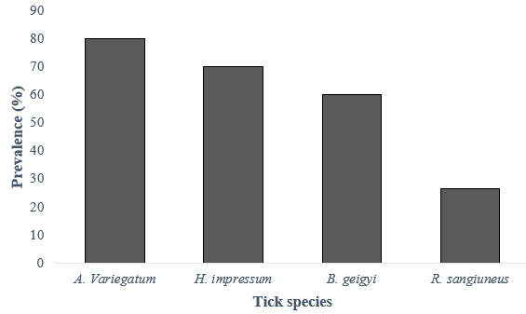

Figure 1: Overall prevalence of ticks on from each cattle at trade market, Edo state.

Table 2: Single and multiple tick infestations in the cattle.

|  |  |  |
| --- | --- | --- |
| Number of Tick Species | Number of cattle infested | Prevalence (%) |
| 1(single) | 0 | 0 |
| 2 (Double) | 5 | 16.7 |
| 3 (triple) | 15 | 50 |
| 4(Quadruple) | 4 | 13.3 |

While most of the cattle sampled for tick infestations had multiple tick infestations, some disparities when checked for per predilection site (Figure 2). All cattle had at least one (1) tick species infestation on their legs, with 17 cattle having triple tick species infestation. Moreover, there were 7-9 cattle without any tick infestation at all predilection sites except the legs. Also, Head, neck, shoulders and belly of the cattle had quadruple infestations (i.e., infestations from the four distinct species of ticks), with 10% of cattle having all four tick species present in the legs and the other quadrupled-tick-infested sites from just one cattle each.

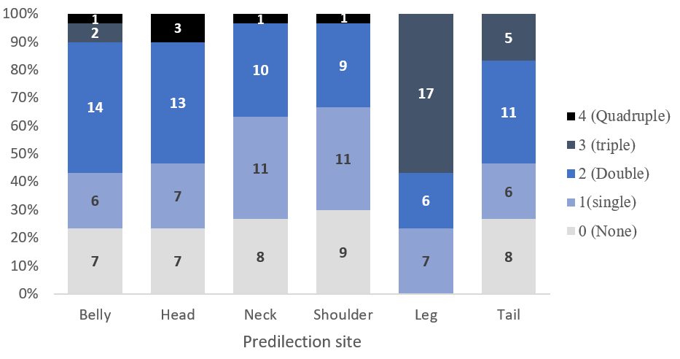

**Figure 2**: Number of cattle and their respective number of distinct tick species infestation. *The bars are colour-graded from light to dark(er) with respect to the level of zero to multiple tick species infestations. The stacked column bar chart represents the count of cattle in their relative abundance (%) for each predilection site. Numbers within the bars represent actual counts of cattle with 0-4 distinct tick species in the respective predilection site. None: Zero tick infestation; Single: 1 tick species infestation; Double: 2 tick species infestation; Triple: 3 tick species infestation; Quadruple: 4 tick species infestation.*

# **Discussion**

In this study, we examined cattle at a trade market in Edo State, Nigeria, to determine the prevalence of tick infestation. We focused on six predilection sites of the cattle’s bodies—head, neck, shoulder, belly, legs, and tail—and assessed the presence of zero, single, and multiple (taxonomically distinct) tick species. This research is crucial because the last published study by Adane et al. (2019) reported a high prevalence of tick infestations, but no subsequent studies have been conducted. Our findings showed an overall tick prevalence of 80%, meaning that out of the 30 cattle surveyed, at least 24 were infested with one or more tick species. This prevalence is about four times higher than the 21.5% reported by Adane et al. (2019), who reportedly conducted a whole-body count for tick infestations on each cattle. Similarly, high prevalence rates have been recorded previously; for instance, Musa et al. (2014) observed a prevalence of 63.4% among 205 cattle surveyed in Maiduguri, Nigeria. In this study, we examined six predilection sites to test for consistency in findings on tick prevalence. Interestingly, the legs were the only predilection site where at least one tick was consistently found across all cattle; in contrast, 7–9 cattle were free of infestation at other predilection sites. Notably, three cattle had all four tick species infesting their heads, resulting in quadruple tick species infestations. This pattern was also observed in one cattle each for the shoulder, neck, and belly. However, it is important to note that most of the sampled cattle legs exhibited triple-tick species infestations.

In our study, *H. impressum* was the most abundant tick species collected across all 30 cattle examined, though it ranked second to *A. variegatum* in infestation prevalence (70%; Figure 1), which can also be considered high. Musa et al. (2014) similarly reported high levels of *Hyalomma* spp. in their inspection of 205 cattle for ticks in Maiduguri, Nigeria, predominantly in the eye, ears, inner thighs, and tail regions. However, *H. impressum* was absent from the findings of Adane et al. (2019). To the best of our knowledge, this study represents the first documented report of *H. impressum* infesting cattle in Edo State, Nigeria. Onyiche et al. (2020) recorded low numbers (n=2) of *H. impressum* from camels examined in Kano, Northwest Nigeria, identifying it as the least prevalent of five *Hyalomma* species collected in that study. Similarly, Mamman et al. (2021) reported nine (9) *H. impressum* among 240 ticks collected in Zamfara and fifteen (15) out of 254 ticks collected from cattle in Sokoto, Nigeria. These ticks are of significant veterinary concern, particularly because *H. impressum* has been identified as a vector of *Theileria annulata*, a parasite causing tropical theileriosis, a severe disease affecting cattle predominantly in North Africa and Asia (Hashemi-Fesharki, 1988; Liu et al., 2022).

*A. variegatum* was the second most abundant tick species observed in our study and the most prevalent tick infesting the cattle we sampled. This finding aligns with numerous studies across West Africa that have documented similarly high occurrences and infestation rates of this species in cattle (Lorusso et al., 2013; Compaoré et al., 2022; Hayatou, 2023). For instance, *A. variegatum* was reported as the most prevalent tick (76%) in a study conducted by Akande et al. (2017) at a cattle ranch in Ogun State, Nigeria. Likewise, Paul et al. (2017) documented a high prevalence of this tick, recording 798 individuals (37.7%) from a sample of 500 cattle in Maiduguri, North-Eastern Nigeria. In contrast, Adene et al. (2019) reported a relatively lower abundance of *A. variegatum* compared to three other tick species surveyed in their study. While we observed a prevalence of *A. variegatum* as high as 80%, Adene et al. (2019) found a considerably lower overall prevalence of just 17.58%.

It can be argued that the high prevalence of ticks observed in our study may be temporally related to the timing and seasonality of sample collection. Adene et al. (2019) noted the highest abundance of ticks occurring between May and July, which aligns with our sampling period conducted in June and July. Nevertheless, the prevalence in our study was significantly higher, suggesting that additional, unaccounted-for factors may contribute to the observed occurrence. For example, a study by Musa et al. (2014) revealed that younger cattle, specifically those under the age of three years, exhibited a significantly higher prevalence of tick infestation at 85.4%, compared to adult cattle aged between three and seven years, which had a prevalence of 55.8%. Additionally, Musa et al. (2014) observed that cattle over seven years old experienced the lowest prevalence of tick infestation, recorded at 35.0%. The study further examined the variation in tick prevalence across different cattle breeds, finding that the Wadara and Kuri breeds exhibited higher prevalence rates compared to the Rahaji, Gudali, and Bunaji breeds. These cattle breeds are particularly prevalent in Edo State, located in Southern Nigeria, which is also the region where this study was conducted.

*B. geigyi* can transmit bacteria such as *Staphylococcus pyogenes* and *Pseudomonas aeruginosa*, through their eggs and larvae (Amoo et al., 1987; Kyari et al., 2022). *B. geigyi* infested 60% of cattle in this study which is concerning, knowing that they have high potential to carry cattle diseases. Also, *R.* *sangiuneus* is not a common tick in Southern Nigeria, however, it has been reported in the Northern region in dogs and cattle. Relatively low prevalence of this tick had been reported in Adejoh et al. (2019). Out of 200 cattle examined, they found a prevalence of 0.5% making it the lowest of all tick species encountered.

We acknowledged that larger cattle are likely to have a greater external body surface area for ticks to attach to, making cattle size a potential factor influencing our results. Rehman et al. (2017)’s study showed that larger livestock had a higher abundance of ticks compared to smaller ones, in their comparison between cattle, buffalo, goats and sheep. They also found that female livestock generally carried a higher number of ticks compared to their male counterparts. Additionally, other variables such as cattle age, breed, and phylogenetic background likely affect their susceptibility to tick infestations (Rehman et al., 2017). Despite these considerations, the consistently high prevalence of ticks observed raises critical questions about the extent to which local vector control efforts are targeted at these ectoparasites.

The observed high tick prevalence in our study highlights a critical concern regarding the control and management of tick infestations in the region. The high prevalence of ticks in our study may be attributed to the trade market setting, where cattle from diverse regions converge, increasing the chances of cross-infestations. Additionally, the absence of rigorous tick control measures in trade markets could contribute to the observed high infestation rates. A study in Cameroon, West Africa, has shown that the invasive *R. micropylus* becomes more easily established from intense movements that occur in cattle trade areas (Lontsi-Demano et al., 2020). The presence of multiple tick species on individual cattle increases the likelihood of co-infections, which can exacerbate disease severity and complicate treatment strategies.

The findings of this study highlight an urgent need for improved tick control measures in Edo State and other regions of Nigeria. Integrated tick management strategies, including regular acaricide treatments, rotational grazing, and the growing of tick-resistant cattle breeds, could be prioritized. Public awareness campaigns targeting cattle owners and traders can also play a vital role in reducing tick infestations and associated health risks. Collaborative efforts between veterinary authorities, researchers, and policymakers are essential to develop and implement sustainable tick management programs that address the specific challenges faced by cattle farmers in Nigeria.

# **Conclusion**

This study serves as an updated record to the state of tick infestation in cattle in Edo State, Nigeria. Tick infestations in cattle are poorly monitored and this is concerning, especially since ticks are of great medical, veterinary and economic importance to Nigeria. We find four tick species in a distinct genus: *A. variegatum, H. impressum. B. geigyi* and *R.* *sangiuneus*. But interestingly, most of the cattle had multiple tick species infestations. On examination of the predilection site of cattle, we find that the legs contained the most tripled-tick-species infestation. This multi-species infestation and the high level of tick prevalence in cattle in of great public health importance and necessitate a rapid response by the government, vector control agencies and animal monitoring agencies to look into this issue.

# **REFERENCES**

Adane, I. O., Okaka, C. E., Aiwaritoma, A. O., Osagie, P. A., & Igetei, J. E. (2019). Prevalence and seasonal variation of ticks in trade cattle consumed in EDO state, Nigeria. Prevalence, 4(5).

Lorusso, V., Picozzi, K., de Bronsvoort, B. M., Majekodunmi, A., Dongkum, C., Balak, G., ... & Welburn, S. C. (2013). Ixodid ticks of traditionally managed cattle in central Nigeria: where Rhipicephalus (Boophilus) microplus does not dare (yet?). Parasites & vectors, 6, 1-10.

Musa, H., Jajere, S., Adamu, N., Atsanda, N., Lawal, J., Adamu, S., & Lawal, E. (2014). Prevalence of Tick Infestation in Different Breeds of Cattle in Maiduguri, Northeastern Nigeria. *Bangladesh Journal of Veterinary Medicine*, *12*(2), 161–166. https://doi.org/10.3329/bjvm.v12i2.21279

Onyiche, T. E., Răileanu, C., Tauchmann, O., Fischer, S., Vasić, A., Schäfer, M., ... & Silaghi, C. (2020). Prevalence and molecular characterization of ticks and tick-borne pathogens of one-humped camels (Camelus dromedarius) in Nigeria. Parasites & Vectors, 13, 1-16.

Mamman, A. H., Lorusso, V., Adam, B. M., Dogo, G. A., Bown, K. J., & Birtles, R. J. (2021). First report of Theileria annulata in Nigeria: Findings from cattle ticks in Zamfara and Sokoto States. Parasites & vectors, 14(1), 242.

Liu, J., Guan, G., & Yin, H. (2022). Theileria annulata. Trends in parasitology, 38(3), 265-266.

Hashemi-Fesharki, R. (1988). Control of Theileria annulata in Iran. Parasitology Today, 4(2), 36-40.

Lontsi-Demano, M., Ngnindji-Youdje, Y., Laroche, M., Bamou, R., Talom, A. D., Abah, S., ... & Tchuinkam, T. (2020). Cattle trading favors the introduction and establishment of the invasive tick *Rhipicephalus (Boophilus) microplus* in Menoua Division, West Region of Cameroon. J. Entomol. Zool. Stud, 8, 207-214.

Rehman, A., Nijhof, A. M., Sauter-Louis, C., Schauer, B., Staubach, C., & Conraths, F. J. (2017). Distribution of ticks infesting ruminants and risk factors associated with high tick prevalence in livestock farms in the semi-arid and arid agro-ecological zones of Pakistan. Parasites & vectors, 10, 1-15.

Compaoré, S., Boungou, M., Biguezoton, A. S., Thiombiano, N. G., Zannou, O. M., Ouedraogo, A. S., & Kabré, G. B. (2022). Tick species infesting cattle in the central region of Burkina Faso: Presence of Rhipicephalus microplus less than ten years after its first identification in the Southwest part of the country. Ticks and Tick-borne Diseases, 13(5), 101983.

Hayatou, H., Meutchieye, F., Amarir, F. E., Rhalem, A., Bouslikhane, M., & Awah-Ndukum, J. (2023). Prevalence of Tick Infestations and Tick-Borne Diseases in Cattle in Cameroon. Open Journal of Animal Sciences, 13(4), 560-573.

Paul, B. T., Bello, A. M., Haruna, N. M., Dauda, J., Ojo, D. T., & Gadzama, M. A. (2017). Infestation of zebu cattle (bos indicus linnaeus) by hard ticks (acari: Ixodidae) in maiduguri, northeastern Nigeria. Persian Journal of Acarology, 6(3).

Akande, F. A., Oyewusi, I. K., Ajisafe, M. G., Idowu, O. A., & Anifowose, I. O. (2017). Survey of cattle tick infestation on farm herds in Ogun state, Nigeria. Nigerian Journal of Animal Production, 44(3), 23-30.

Amoo, A. O., Dipeolu, O. O., Akinboade, A. O., & Adeyemi, A. (1987). Bacterial isolation from and transmission by Boophilus decoloratus and Boophilus geigyi. Folia Parasitologica, 34(1), 69-74.

Kyari, S., Ogwiji, M., Igah, O. E., Orakpogheno, O., & Gasaliyu, K. A. (2022). Current distribution and disease association of Ixodidae (hard ticks) in Nigeria. The Journal of Basic and Applied Zoology, 83(1), 42.

Adejoh, V. A., Pam, V. A., Uzoigwe, N. R., Naphtali, R. S., Yohanna, J. A., Pam, R. G., & Ombugadu, A. (2019). A survey of ticks and tick-borne parasites in commercial cattle at Lafia, Nasarawa State, Nigeria. Nigerian Journal of Parasitology, 40(2).